Appendix 3: Site Environmental Control Report

Site Environmental Control Report

Instructions for the Site Environmental Control Report (SECR):

- The ECO(SCS) and Occupier shall prepare the SECR at least once a month or any other frequency as NEA may require, after the commencement of works on the specified construction site.
- The reports shall be filed and made available onsite for inspection by the National Environment Agency and/or any public health officer, when required.
- The examples in the Sections A – D are given as a guide. ECOs(SCS) shall prepare the SECR with inputs specific to the Construction Site where he/ she is appointed in.
---------------------------------------------------------------------------------------------------------------------------

SITE ENVIRONMENTAL CONTROL REPORT (SECR)

For: _____ (date) _____ to _____ (date) _____.

The SECR serves to facilitate reviews of efforts implemented in the construction site. Where applicable, improvements should be proposed to enhance current efforts prescribed in the SECP.

Section A: Review Efforts for Vector Control, Waste Management and Food Hygiene
1 | Surveillance and housekeeping efforts implemented at high-risk areas  Examples:  - Inspections conducted weekly across zones (a maximum of 6 zones assuming a 6-days work week or 7 zones for a 7-days work week)  - Removed receptacles and levelled ground depressions in the open  - Workers quarters and pantries kept tidy and free from food waste
1a | Measures to ensure cleanliness of canteen and/or dining areas  - Provision of food waste bins  - Canteen and dining areas cleaned daily after meals
1b | Measures to ensure good food storage practices  - Appropriate temperature and containers  - Food delivery not left unattended on floor  - Proper cold chain
1c | Measures to ensure proper waste management  - Uncovered/ damaged bins with refuse spillages  - Disposal of waste into correct type of bins  - Waste are collected and transported for disposal properly
2 | Measures to ensure effective vector control  - Use of larvicides and AM oil in areas where stagnant water cannot be removed  - Structural defects discovered to be rectified as soon as possible
3 | Measures taken when site is located in a dengue cluster (to be updated when site is located in a dengue cluster)  - Indicate the measures taken by Construction Site
4 | Evaluation of the performance of Vector Control Operator(s) (VCO):  - Service reports by VCOs were comprehensive.  - If chemical applications were made, the VCO had indicated the reasons(s), type of chemical and dilution rate used in the Service Reports.  - Treatment carried out were effective. Soil treatment by VCO complied with water pollution control requirements.

Section B: Photograph(s) (with timestamp) of site conditions at Areas of Concern
Construction Area  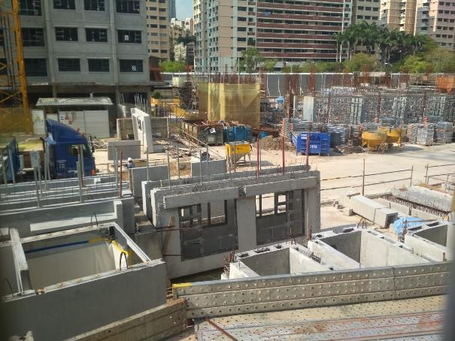  Observation: No sighting of stagnant water in Construction Area, worksite is kept litter free. | Workers Quarters  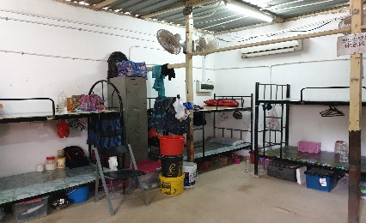  Observation: Workers Quarters are kept litter free
Storage Yard  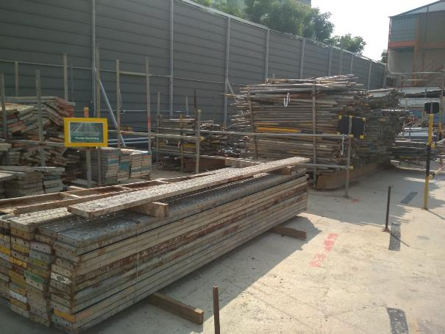  Observation: Storage of materials should preferbly be under shelter to prevent collection of rain water | Toilet(s)  Observation: Stagnant water due to poor gradient
Basement (if applicable)  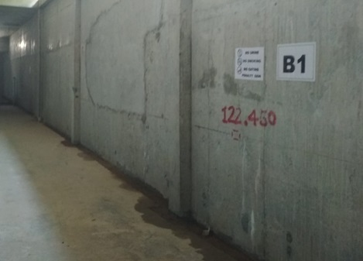  Observation: Stagnant water in scupper drain | Canteen and Dining Area  Observation: No leftover/ uncleared food at dining area

Section C: Review Efforts for Pollution Control
1 | Measures to prevent smoke and dust nuisance  - Service faulty machinery  - Vehicles are covered and not overloaded  - Water-spray at wash bay
2 | Measures to prevent noise pollution  - Siting of generators and machineries  - Restrict timing of noisy activities  - Service faulty machinery
3 | Steps to ensure effective earth control  - Perimeter cut-off drains, silt traps, silt fences and silty water treatment plant

Section D: Review efforts for Prevention of Infectious Diseases
1 | Measures to prevent spread of infectious diseases in the construction site.  - Temperature checks for workers and visitors  - Workers who are unwell (> 37.5⁰C) not be allowed to continue work

Section E: Environmental Outreach and Training Conducted e.g. Toolbox Meeting
Date | - Outreach and Training Conducted

I certify that the SECR is prepared to the best of my knowledge.
Name of ECO(SCS) and license expiry date | Signature of ECO(SCS) | Date prepared

I acknowledge the assessment(s) provided by ECO(SCS) and have/will complete(d) the necessary follow up action(s) required
Name of Contractor | Signature of Contractor | Company Stamp

