QRA Submission Format

[Revision No: 3]

[Date of Revision: 06 Aug 2019]
  - Contents
1 QRA Assessment Process 2
1.1 Process with Major Hazards Department 2
1.2 QRA report submission 2
2 QRA Report Submission 2
2.1 Data files 2
2.2 Report Structure 3
3 Contact Details 17
3.1 Pre-consultations on QRA-related issues 17
3.2 QRA report submissions 17

QRA Assessment Process

Process with Major Hazards Department

Figure 1 QRA assessment process
The Responsible Party is advised to approach the Major Hazards Department (MHD) at the earliest possible time (e.g. basic concept and design stage / pre-Front End Engineering Design (FEED) stage) for pre-consultations (e.g. need for QRA study, expected timeline) and clarifications, to facilitate the QRA assessment process.

QRA report submission
Upon completion of the QRA study, one (1) written hardcopy and one (1) PDF softcopy of the QRA report shall be submitted to all relevant agencies as indicated in Section 3.

The structure of the QRA report shall follow the format set out in Section 2.

QRA Report Submission
The QRA Report Submission consists of a report outlined below and a set of data files noted in the outline.

Data files
The data files formats required for the QRA submission are defined below, along with coordinate system and file naming convention. The data files required are identified in the report structure below.

Coordinate system
The main coordinate system used in Singapore is SVY21 which is a grid covering the area of Singapore. All coordinates in the QRA report submission should use this SVY21 system. It is available as a coordinate system in most GIS software including some freely downloadable versions.

File formats
Various electronic files are required as identified below. The three main formats are:
- CSV (.csv) - This is a record format using commas to separate fields of data. This is a generally well understood file format although there are some variations in its use. The conventions noted in various QRA critieria are known to be followed by use of “Save As…” in some versions of Excel. The following conventions are specified:
- A single header row should be included and having the same number of fields as a record line.
- All record lines should have the same number of fields.
- Numerical data should appear directly and should not include commas or double quotes within the field.
  - Date data should be stored as day/month/year, e.g 20/12/2013.
  - Text data should be surrounded by double quotes, i.e. “…” if it contains commas or double quotes.
  - Commas may only be included in text data when double quotes have been used to surround the field e.g. “aaa, bbb”.
  - Double quotes (“) may only be included in text data when double quotes have been used to surround the field and should be preceded by an additional double quote ("") e.g. “aaa ""bbb""”.
  - Fields should avoid line breaks within the data, but if included should be within a double quoted field.
- Shapefile (.shp, …) - This is a commonly used vector based format for geographic information exchange. It consists of a set of files that store point, line and polygon information (.shp, .shx) along with records of data (.dbf) and optional projection (.prj). The coordinates should conform to SVY21 whether a projection file is included or not. If included the projection should be SVY21. The records of data are optional although the file is usually not. Use of shapefiles includes representation of release locations, site boundary outline, risk contours and transport and pipeline routes.
- ASCII (.asc) - This is a raster file format that can be used to transfer cell or grid information like risk grids. It is a single file with the .asc extension. The file consists of some header information and then the data values. The header information includes the number of cells, the position of a specific cell which should correspond to SVY21 coordinates, the cell size and a no data value which would be interpreted as missing data. The data values are separated by spaces and provided row by row. The data values start with the top left cell. An example is shown in Figure 3. The coordinates of the lower left cell is provided either by corner, or centre, usually the corner (lower left corner of this cell).

File naming convention
The filename should include an appropriate reference to the installation and company at the start of the filename. For locations, the same reference used in the scenario data should be used in the filename. Refer to Annex A for more details.

Report Structure

Site information
The following are required in this Section:
- Describe the approved/proposed industrial activity.
- Describe the hazards of the hazardous materials that will be used, stored or transported.
- Labelled site map showing the facility/pipeline route/transport route, occupied buildings and sensitive receptors (on-site and off-site where relevant). For further details on what should be included in the site map, please refer to Section 2.2.1.2.
- Tabulation of the inventory of hazardous materials to be handled/stored/transported (refer to Section 2.2.1.3 for further details). SDSs or MSDSs are to be included.

Process Description
A brief description of the processes involved should be provided, including:
- Capacity, design pressure/temperature, operating pressure/temperature and function (e.g. storage tank, reactor, distillation column, pipeline, transport container) of relevant process equipment;
- Brief description of the main process activities, operating methods, control;
- Description of proposed measures to prevent accident scenarios, with any applicable references to relevant good practice.

Site maps

Site maps in the report
A site map should be presented in the report. It should clearly identify, label and show locations of the following as a minimum:
- Site Boundary and main plant areas;
- Tanks, vessels, reactors, and main items of equipment (e.g. distillation column);
- Items of equipment that contribute to event outcomes belonging to the following categories:
  - WCS and WCS-offsite (extracted from the list of event outcomes in Table 17);
  - CE and CE-offsite (extracted from the list of event outcomes in Table 20);
- On-site occupied buildings;
- Sensitive receptors (on-site and off-site where relevant).

Site maps in other file formats
In addition to presenting a site map in the report, a shapefile (.SHP) of the site map referenced to the SVY21 coordinate system should also be provided. These files shall be stored in the “SHP” folder (refer to Annex A). This site map should include related attribute information for the items as shown below. Please refer to Annex A for the actual attributes/fields to be provided inside the shapefiles.

Table 1: Generalized attributes for site map in shapefile format
Item | Shapefile name | Attribute
Site Boundary | SiteBoundary
Main plant areas | MainPlantArea | Area description (type and label)
Tanks, vessels, reactors, and main items of equipment (e.g. distillation column) | MajorEquipmentPoint (for point based items) OR  MajorEquipmentLine (for line-based items) | Material, quantity/flowrate, temperature, pressure, items to be labelled with the iso-section ID that it belongs to
Items of equipment that contribute to event outcomes which belong to the following categories:  - WCS and WCS-offsite (extracted from Table 17)  - CE and CE-offsite (extracted from Table 20) | MajorEquipmentPoint (for point based items) OR  MajorEquipmentLine (for line-based items) | Items to be labelled with the outcome ID¹ that it contributes to
On-site occupied buildings | OccupiedBld | Building ID¹, estimated number of people, protection measures (if any)
Location of Potential Explosion Domain (PED) | PED | PED description

Note that a Single shape file has to be provided for each category of items; e.g. all the iso-sections and items of equipments for point-based items will need to be given as a single shape file called MajorEquipmentPoint.shp. Additionally, a dummy or empty shapefile has to be provided if there are no data available for that item.

Inventory
A tabulation of inventory shall be presented as shown below.

Table 2: Fixed Installation
Chemical | Storage Location | GHS/UN / IMO  Hazard  Class | Major Hazards | Physical  Form | Type of Container | Unit  Capacity of  Container | Max Quantity  Stored  On-Site⁶
Note: this should include any transport containers used as on-site storage, in which case the number and percentage of time they are present on-site should be included.

Table 3: Pipeline
Chemical² | From | To | GHS/UN / IMO  Hazard  Class | Major Hazards³ | Physical Form⁴ | Pipeline Dimensions (length, diameter and thickness) | Volume and Flow rate | Construction Material | Operating Conditions (if different from atmospheric) | Control Measures

Table 4: Bulk Transport
Chemical² | From | To | GHS/UN / IMO  Hazard  Class | Major Hazards³ | Physical Form⁴ | Type of Container⁵ | Unit  Capacity of  Container⁶ | Max Quantity  Transported per trip⁶ | No. of Unit  Containers  Transported per trip | No. of  Trips per year

Meteorology
Weather categories modelled should be specified. For the Individual risk calculation, the splits used should be provided as in the following table.

Table 5: Meteorology
% split between weather categories (breakdown by time of day if included in QRA)
F1 | B2 | C3 | Total
% | % | % | 100%
Wind directions and percentage time in each direction (confirm whether data in Section 6.2.2 of the QRA Technical Guidance has been used. Provide table of values used and justification if not.)
Temperature used for consequence modelling
% Humidity
Solar radiation used for consequence modelling (if relevant)

Hazard Identification
The approach used for hazard identification should be specified:
- method employed, e.g. top-down guideword-driven study, more detailed study such as HAZOP
- relevant experience of team members.

Iso-sections
A table containing Parts Count information shall be provided.

Event Outcomes
The following table shall be provided in the report.

Table 6: Event Outcomes
Iso-section ID | Description |  | State | Temperature (°C) | Pressure (barg) | Volume (m³) | Inventory (kg) | Outcome | Outcome ID⁷ | Justification
 | Iso-section | Event
XX-000-YY-00 | 4” piping from V01 Vessel to P01 Pump | Rupture of Vessel | Solid/Liquid |  |  |  |  | Jet Fire | V01_R_JF
 |  |  |  |  |  |  |  | Pool Fire | V01_R_PF
 |  |  |  |  |  |  |  | Toxic Release | V01_R_TX

In addition, a CSV file containing the following data describing the outcomes shall be provided. The file shall be named as “KeyEventOutcome.csv” only and stored in the “CSV” folder.
The CSV file shall contain the following headers and information:

Table 7: CSV file for key event outcomes
Outcome_ID | x_point | y_point | ISO_Sect_ID | Category | Outcome_Desc | Weather | Dimension_D | Dimension_minus_D | Dimension_DMW | Dimension_MW | Report_Date
V01_R_JF | x | y | XX-000-YY-00 | WCS | Jet Fire, 4kW/m2 | 1F
V02_R_OP | x | y | XX-001-YY-01 | CE | Explosion at 2psi | 2B
V03_R_FF | x | y | XX-002-YY-02 | CE-O | Flash fire at 20kW/m² | 3C
PL01_R_PF | x₁|x₂|x₃ | y₁|y₂|y₃ | XX-003-YY-03 | WCS-O | Pool Fire at 4kW/m2 | 3C

Figure 2: Sample key event outcomes in CSV format
V01_R_JF,1000,1000,XX-000-YY-00,WCS,”Jet Fire, 4kW/m2”,1F,40.00,10.00,30.00,20.00,29/07/2015
V02_R_OP,2000,2000,XX-001-YY-01,CE,”Explosion at 2psi”,2B,40.00,40.00,0.00,80.00,29/07/2015
V03_R_FF,3000,3000,XX-002-YY-02,CE-O,”Flash Fire at 20kW/m2”,3C,400.00,50.00,350.00,200.00,29/07/2015
PL01_R_PF,4000|4010|4020,4000|4010|4020,XX-003-YY-03,WCS-O,”Pool Fire at 4kW/m2”,3C,40.00,38.00,2.00,39.00,29/07/2015

Please refer to Annex A for more details.

Frequencies
Modifiers used must be specified and justified. Event trees should be included, expanded from those in Section 4.2 of the QRA Technical Guidance to show modifiers that have been included in the analysis.

Consequences
Details of any probits used should be specified and justified.
Details of the software and models used, including version number, should be given, with justification of appropriateness. Inputs and assumptions should be specified.
Table 8: Inputs to consequence models
Outcome ID | Consequence | Model/ software | Input assumptions | Justification for model and input assumptions

Individual risk and Cumulative Escalation risk
Software and approach used. Confirmation that the methodology is consistent with that specified in Section 6 of the QRA Technical Guidance should be provided. In exceptional cases, justification for use of a modified approach should be provided. Note that this is important that all QRAs follow these Guidelines so as to be consistent.

On-site occupied buildings
Methodology used, harm levels and occupancy modifiers shall be specified and justified.

Harm Zones for Consequence Results

Table 9: Tabulation of Worst Case Scenario zones
Hazard Type | Outcome ID¹⁵ | Maximum Distance for WCS-Offsite | Maximum Distance (relative to Boundary) for WCS-Offsite | Outcome ID¹⁵ | Maximum Distance for WCS¹⁷ | Maximum Distance (relative to Boundary) for WCS
Fire
Explosion
Toxic dispersion

For Bulk Transport QRA, a confirmation table (example shown below in Table 10) shall be presented in the report:

Table 10: Confirmation that WCS-offsite (for Bulk Transport QRA) meets criteria
WCS-offsite | Maximum Distance¹⁷ | Confirmation
Fire |  | Confined to industrial and commercial developments only and shall not reach sensitive receptors
Explosion
Toxic dispersion

Table 11: Tabulation of Fireball Scenario zones
Hazard Type | Outcome ID¹⁵ | Maximum Distance¹⁷
Fire

Table 12: Tabulation of ERPG-2 Scenario zones
Hazard Type | Outcome ID | Maximum Distance
Toxic

Table 13: Tabulation of Cumulative Escalation Scenario zones
Hazard Type | Outcome ID¹⁸ | Maximum Distance for CE-Offsite¹⁹ | Maximum Distance (relative to Boundary) for CE-Offsite | Outcome ID¹⁸ | Maximum Distance for CE¹⁹ | Maximum Distance (relative to Boundary) for CE
Fire
Explosion

Harm Footprints (IR Fatality)
For IR (Fatality), the footprint dimensions (rounded to the nearest metre) shall be provided such as maximum hazard distance, maximum width, distance to maximum width and minimum distance, as specified in Section 5.4 of the QRA Technical Guidance.

Table 14: IR (fatality) scenarios
Event Description | Mass Released (kg) | Release Size (mm) | Release Rate (kg/s) | Release Duration (min) | Outcomes |  | Outcome ID¹⁸ | Weather | Footprint dimensions |  |  |  | Outcome Frequency | Key Assumptions  Safety/Mitigation Measures
 |  |  |  |  |  |  |  |  | d | -d | dmw | mw
Rupture of Vessel |  |  |  |  | Toxic | Refer to Table 6 of the QRA Technical Guidance |  | 1F  2B  3C |  |  |  |  | -
 |  |  |  |  | Thermal radiation from fire scenarios (e.g. Fireball, Jet Fire, Pool Fire) |  |  |  |  |  |  |  | -
 |  |  |  |  | Overpressure from explosion scenarios (e.g. BLEVE, VCE) |  |  |  |  |  |  |  | -

Table 15: Confirmation that IR (fatality) contours meet criteria
A confirmation table (example shown below for Fixed Installation) shall be presented in the report:

Individual Fatality Risk (IR) Contours | Maximum Distance | Confirmation
5x10⁻⁵ per year |  | This contour remains on-site
5x10⁻⁶ per year |  | This contour extends into industrial developments only.

A shapefile of the risk contours (shown in Table 15) shall be provided (one shapefile per contour). The shapefile should be named “FATALITY 5E-5.shp” as an example. The file name shall contain the Criteria and harm level information. The files shall be stored in the “SHP” folder. Refer to Annex A for more details. A risk grid for Fatality risk values shall be provided in ASCII grid file or CSV file, 10m spacing and be aligned to SVY21 coordinate system. If it is ASC file, it MUST BE accompanied by a .PRJ file (which is a Projection file that specifies the coordinate system). The files shall be stored in the “GRID” folder. Refer to Annex A for more details. Sample risk grids are shown in Figures 3 and 4 below.

Figure 3: Sample risk grid in ASCII format
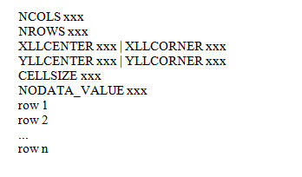
Figure 4: Sample risk grid in CSV format
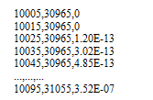

Harm Footprints (IR Injury)
For IR (Injury), the footprint dimensions (rounded to the nearest metre) shall be provided such as maximum hazard distance, maximum width, distance to maximum width and minimum distance, as specified in Section 5.4 of the QRA Technical Guidance.
Table 16: IR (injury) scenarios
Event Description | Mass Released (kg) | Release Size (mm) | Release Rate (kg/s) | Release Duration (min) | Outcomes |  | Outcome ID | Weather | Footprint dimensions |  |  |  | Outcome Frequency | Key Assumptions  Safety/Mitigation Measures
 |  |  |  |  |  |  |  |  | d | -d | dmw | mw
Rupture of Vessel |  |  |  |  | Toxic | Refer to Table 7 of the QRA Technical Guidance |  | 1F  2B  3C |  |  |  |  | -
 |  |  |  |  | Thermal radiation from fire scenarios (e.g. Fireball, Jet Fire, Pool Fire) |  |  |  |  |  |  |  | -
 |  |  |  |  | Overpressure from explosion scenarios (e.g. BLEVE, VCE) |  |  |  |  |  |  |  | -

A confirmation table (example shown below for Fixed Installation) shall be presented in the report:

Table 17: Confirmation that IR (injury) contours meet criteria
Individual Fatality Risk (IR) Contours | Maximum Distance | Confirmation
3x10⁻⁷ |  | Confined to industrial and commercial developments only and shall not reach sensitive receptors

A shapefile of the risk contours (shown in Table 18) shall also be provided (one shapefile per contour). The shapefile should be named “INJURY 3E-7.shp” as an example. The files shall be stored in the “SHP” folder. Refer to Annex A for more details. The file name shall contain the Criteria and harm level information. A risk grid for Injury risk values shall be provided in ASCII grid file or CSV file, 10m spacing and be aligned to SVY21 coordinate system. Refer to Figures 3 and 4.

Harm Footprints (Cumulative Escalation)
For Cumulative Escalation, the footprint dimensions (rounded to the nearest metre) shall be provided such as maximum hazard distance, maximum width, distance to maximum width and minimum distance, as specified in Section 5.4 of the QRA Technical Guidance.

Table 18: Escalation scenarios
Event Description | Mass Released (kg) | Release Size (mm) | Release Rate (kg/s) | Release Duration (min) | Outcomes |  | Outcome ID | Weather | Footprint dimensions |  |  |  | Outcome Frequency | Key Assumptions  Safety/Mitigation Measures
 |  |  |  |  |  |  |  |  | d | -d | dmw | mw
Rupture of Vessel |  |  |  |  | Thermal radiation from fire scenarios (e.g. Fireball, Jet Fire, Pool Fire) | Refer to Table 8 of the QRA Technical Guidance |  | 1F  2B  3C |  |  |  |  | -
 |  |  |  |  |  |  |  |  |  |  |  |  | -
 |  |  |  |  | Overpressure from explosion scenarios (e.g. BLEVE, VCE) |  |  |  |  |  |  |  | -

A confirmation table (example shown below for Fixed Installation) shall be presented in the report:

Table 19: Confirmation that cumulative escalation risk meets criteria
Cumulative escalation Contours | Maximum Distance | Confirmation
1x10⁻⁴ per year of escalation risk |  | That this contour does not extend beyond the Boundary

A shapefile of the risk contours (shown in Table 21) shall also be provided (one shapefile per contour). The shapefile should be named “ESCALATION 1E-4.shp” as an example. The files shall be stored in the “SHP” folder. Refer to Annex A for more details. The file name shall contain the Criteria and harm level information. A risk grid for Escalation risk values shall be provided in ASCII grid file or CSV file, 10m spacing and be aligned to SVY21 coordinate system. Refer to Figures 3 and 4.

Occupied buildings
For on-site occupied buildings, the footprint dimensions (rounded to the nearest metre) shall be provided such as maximum hazard distance, maximum width, distance to maximum width and minimum distance, as specified in Section 5.4 of the QRA Technical Guidance.

Table 20: Occupied Building scenarios
Building ID²⁵ | Event Description | Mass Released (kg) | Release Size (mm) | Release Rate (kg/s) | Release Duration (min) | Outcomes |  | Outcome ID | Weather | Footprint dimensions |  |  |  | Outcome Frequency | Key Assumptions  Safety/Mitigation Measures
 |  |  |  |  |  |  |  |  |  | d | -d | dmw | mw
B01 | Rupture of Vessel |  |  |  |  | Thermal radiation from fire scenarios (e.g. Fireball, Jet Fire, Pool Fire) | Refer to Table 9 of the QRA Technical Guidance |  | 1F  2B  3C |  |  |  |  | -
 |  |  |  |  |  |  |  |  |  |  |  |  |  | -
 |  |  |  |  |  | Overpressure from explosion scenarios (e.g. BLEVE, VCE) |  |  |  |  |  |  |  | -
B02

A confirmation table (example shown below for Fixed Installation) shall be presented in the report:

Table 21: Confirmation that occupied building risk meets criteria
Building ID²⁵ | Individual Fatality Risk Value | Confirmation
B01 | 1x10⁻³ per year | Not exceeded at the building.

Information relating to the occupied buildings shall be provided in the report as shown in table 25 below.

Table 22: Occupied building IR (Fatality)
Building ID²⁵ | Building Description | Occupancy | IR (Fatality)
B01 | Control Room/Office

A CSV file containing the following data describing the occupied buildings shall also be provided, as shown in Table 26 and Figure 5 below.

Table 23: CSV file for building risk values
X_Point | Y_Point | Building_ID | Risk_Value | Date
x | y | B01 | 1.00E-08 | 20/03/2015

Figure 5: Sample building risk values in CSV format

QRA results to be presented on a map in the report
The following plots shall be provided on a clear site map in the report. Maps should be to scale and be referenced to the SVY21 coordinate system.

Consequence results:
- WCS-offsite and WCS harm zones for fire, explosion and toxic dispersion;
- CE-offsite and CE harm zones for fire and explosion;
- ERPG-2 zone;
- Fireball zone.

Risk results:
- IR (Fatality):
  - IR contours;
- IR (Injury):
  - IR contours;
- Cumulative Escalation:
  - Risk contour (2psi, 20 kW/m²);
- Occupied Building risk level to be indicated.

Domino Information
Tabulation for the event outcomes that have offsite impact shall be provided. This should include all event outcomes whose harm contours extend beyond the Boundary, even if the land concerned is currently a greenfield site or the sea (if land might subsequently be reclaimed or is used for berthing ships).

Table 24: Domino information
Risk Type | Hazard Type | Outcome ID | Maximum Distance
Fatality | Fire  Explosion  Toxic
Injury | Fire  Explosion  Toxic
Escalation | Fire  Explosion  Toxic

Top Risk Contributors
Top risk contributors for each criterion shall be presented as follows.

Table 25: Top risk contributors for Fatality
Outcome ID²⁹ | Outcome Description | Risk (per year) | Risk Contribution (%)
 | Pool Fire due to Rupture of Reactor |  | <ranked in descending order>

Table 26: Top risk contributors for Injury
Outcome ID²⁹ | Outcome Description | Risk (per year) | Risk Contribution (%)
 | Pool Fire due to Rupture of Reactor |  | <ranked in descending order>

Table 27: Top risk contributors for Escalation
Outcome ID²⁹ | Outcome Description | Risk (per year) | Risk Contribution (%)
 | Pool Fire due to Rupture of Reactor |  | <ranked in descending order>

Table 28: Top risk contributors for On-site Occupied Building
Building ID | Outcome ID³¹ | Outcome Description | Risk (per year) | Risk Contribution (%) | Estimated Population | PLL
B01 |  | Pool Fire due to Rupture of Reactor |  |  |  | <ranked in descending order>

Contact Details

Pre-consultations on QRA-related issues

The Responsible Party is advised to approach the MHD for pre-consultations and clarifications, to facilitate the QRA assessment process.

Major Hazards Department (MHD)
1500 Bendemeer Road #03-02 S(339946)
Attn: Mr Chen Fu Yi / Mr Chui Jian Wei
Tel: 64385122
Fax: 65356726
Email: Contact_MHD@mom.gov.sg
*hardcopy not required

QRA report submissions

Upon completion of the QRA study, a copy of the QRA report shall be submitted to each of the following agencies:

National Environment Agency (NEA)  Central Building Plan Dept  40 Scotts Road #12-00, S(228231)  Attn: Ms Lim Jia Fang / Ms Amanda Wong  Tel: 67319919  Fax: 67319725  Email: lim_jia_fang@nea.gov.sg / amanda_wong@nea.gov.sg | Singapore Civil Defence Force (SCDF)  Hazmat Department  91 Ubi Ave 4, S(408827)  Attn: MAJ Ng Huan Chao  Tel: 68483323  Fax: 68483318  Email: ng_huan_chao@scdf.gov.sg
Ministry of Manpower (MOM)  Occupational Safety and Health Division  Major Hazards Department  1500 Bendemeer Road #03-02  Singapore 339946  Attention: Mr Chui Jian Wei  Tel: 64385122  Fax: 65356726  Email: chui_jian_wei@mom.gov.sg | Singapore Police Force (SPF)  Protective & Maritime Security  Security & Counter Terrorism Division,  Operations Dept  Police Headquarters, New Phoenix Park  28 Irrawaddy Road, Singapore 329560  Attn: Mr Dezmand Chen/ Mr. Tok Wee Peng  Tel: 64782309  Fax: 62506306  Email: Dezmand_Chen@spf.gov.sg / TOK_Wee_Peng@spf.gov.sg
*Jurong Town Corporation (JTC)  Land Resource Planning Dept  8 Jurong Town Hall Rd, S(609434)  Attn: Ms Lillian Lee Jiaxian  Tel: 68833129  Fax: 68855880  Email: lillian.lee@jtc.gov.sg | Urban Redevelopment Authority  Physical Planning Group  45 Maxwell Road, The URA Centre, Singapore 069118  Attn: Mr. Shawn Tan  Tel: 63293392  Fax: 63203546  Email: shawn_tan@ura.gov.sg

ELECTRONIC FILES SUBMISSION INSTRUCTIONS
Note that the following only describe the content of the ZIP file rather than the information of the QRA Report (PDF Document).
To view the details of the sample SHP file, please download OpenJUMP GIS which can be downloaded online.
All map data must be in SVY21 coordinate system.
The following are folder structure of QRA Submission ZIP File.
Main Folder | Parent Folder | Sub Folders | Description
Zipped Folder |  |  | The file to be uploaded shall be a .zip file, there is no restriction on the zip file name. The zipped folder contains all the sub-folders and valid files. Only 1 zip folder is allowed.  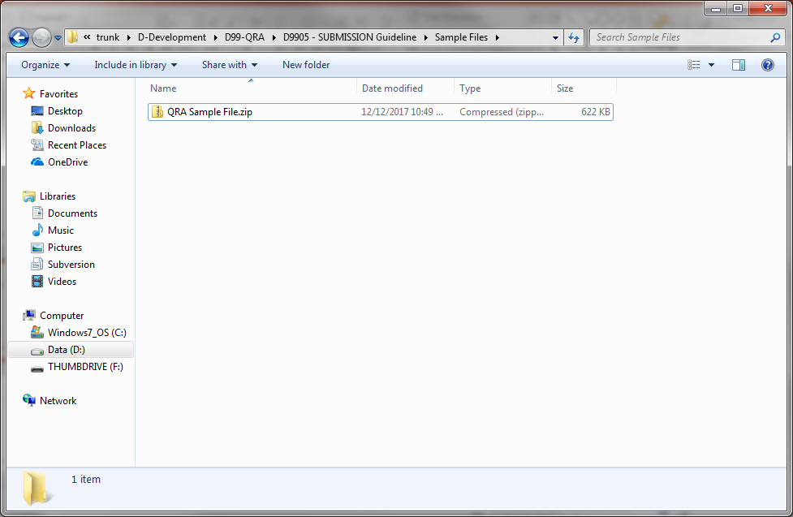  Figure 2 Sample File – QRA Sample File.zip
 | QRA (Root Folder) |  | “QRA” is the root folder in the zip file. This folder MUST BE named as “QRA” only.  It consists of the following sub-folders :  - CSV  - GRID  - PDF  - SHP  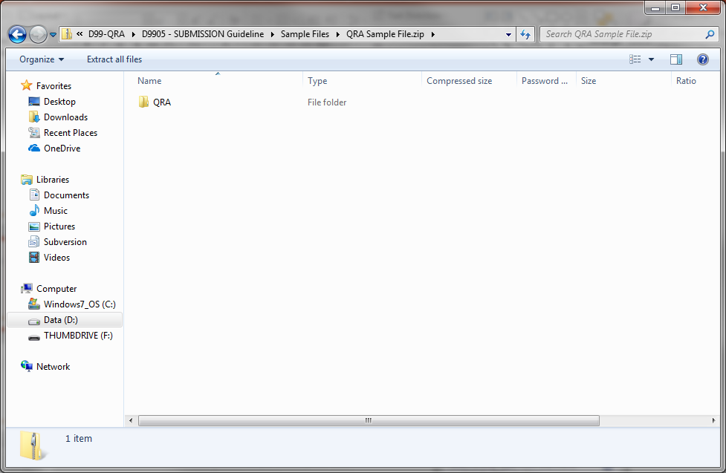  Figure 3 Sample File - QRA root folder  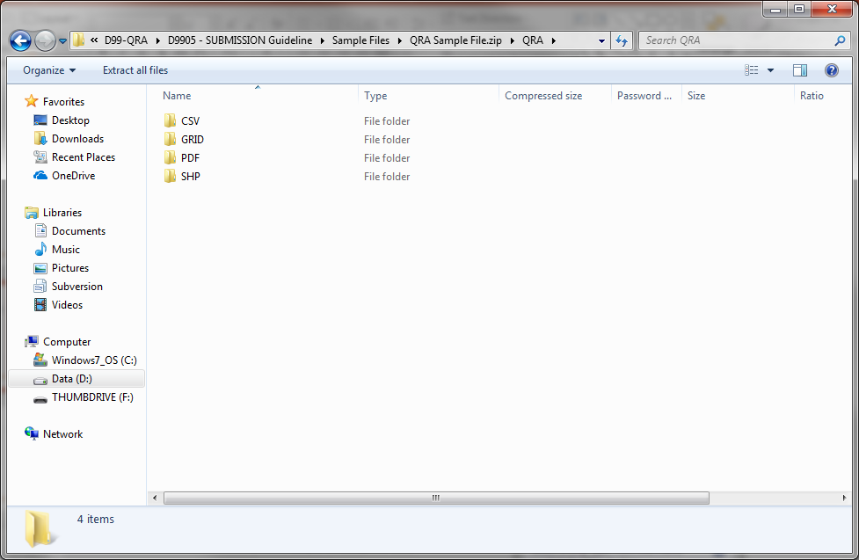  Figure 4 Sample file - 4 Sub folders in QRA root folder: CSV, GRID, PDF, SHP
 |  | CSV (Sub Folder) | Contains the key event outcome and occupied building risk CSV file (as per the revised QRA guideline)  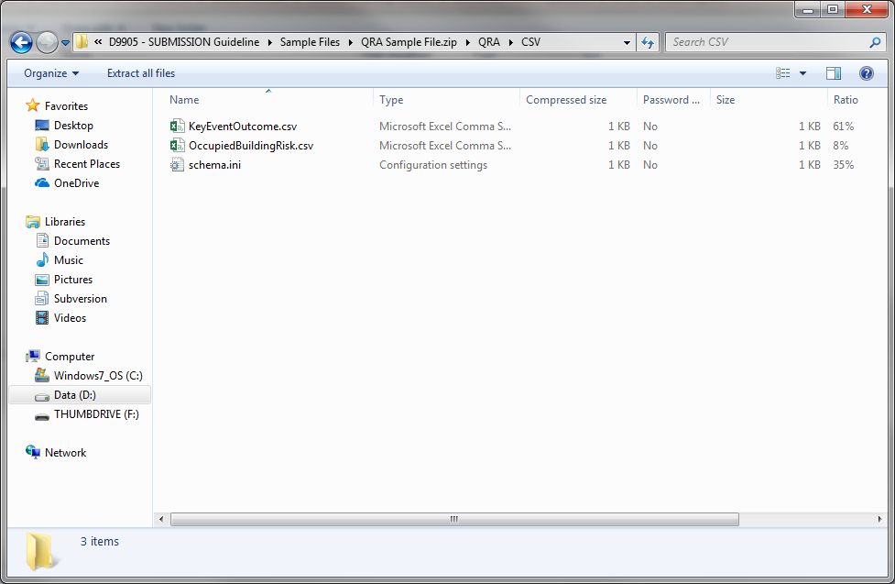  Figure 5 Sample Files under CSV folder
KeyEventOutcome.csv [COMPULSORY] – MUST BE named as “KeyEventOutcome.csv” only.
- Key event outcome CSV files, as mentioned in Section 2.2.4 of the QRA Submission Guidelines, are compulsory files which MUST BE submitted.
- It MUST contain the following headers and the name of the headers MUST BE named as follows:
- Outcome_ID: (string)
- x_point: (decimal) For pipeline, X point and Y point shall be grouped under its respective column.
Each point MUST BE separated by “|” character. For example: x1|x2|x3 (for X points) and y1|y2|y3 (for Y points)
- y_point: (decimal) For pipeline, X point and Y point shall be grouped under its respective column.
Each point MUST BE separated by “|” character. For example: x1|x2|x3 (for X points) and y1|y2|y3 (for Y points)
- ISO_Sect_ID: (string)
- Category: (string) Valid category MUST BE WCS, WCS-O, CE and CE-O.
Category cannot be combined such as “WCS & WCS-O”, if the same record contains multiple key events, they MUST BE split into separate records with the category WCS and WCS-O respectively.
- Outcome_Desc: (string) event outcome and harm level MUST BE separated by “,” or “at”. For example: Jet fire, 4 kW/m2 or Jet fire at 4 kW/m2
For the event outcome naming, it is case-insensitive. Valid event outcome naming are:
- JetFire, Jet Fire
- Poolfire, Pool fire
- Fireball
- Rooffire, roof
- Flashfire, Flash fire
- Toxic, dispersion, toxic dispersion
- Explosion, exp, vapour, vce, cloud, vaporcloud, vaporcloudexplosion
- Bleve

- Weather: (string) Valid weather value MUST BE 1F, 2B and 3C
- Dimension_D: (integer)
- Dimension_minus_D: (integer) If no value, use “- “(hyphen) character
- Dimension_DMW: (integer) If no value, use “- “(hyphen) character
- Dimension_MW: (integer) If no value, use “- “(hyphen) character
- Report_Date: (date) date format MUST BE “dd/mm/yyyy”

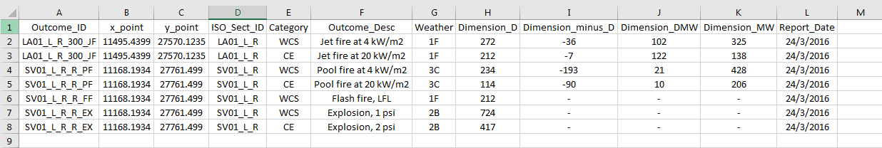
Figure 6 Sample KeyEventOutcome.csv details
OccupiedBuildingRisk.csv [COMPULSORY] – MUST BE named as “OccupiedBuildingRisk.csv” only.
- Occupied building risk CSV files as mentioned in Section 2.2.4.9 of the QRA Submission Guidelines (Table 26 & Figure 5), are compulsory files which MUST BE submitted
- It MUST contain the following headers and the name of the headers MUST BE named as follows:
- X_Point: (decimal)
- Y_Point: (decimal)
- Building_ID: (integer / string)
- Risk_Value: (string)
- Date: (date) date format MUST BE “dd/mm/yyyy”

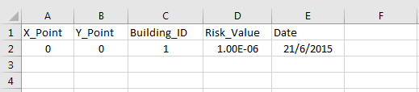
Figure 7 Sample OccupiedBuildingRisk.csv details
If there are no occupied building data associated with QRA, the CSV file must still be present. In this case, please provide the CSV file with the headers only; e.g. not data underneath the header row.

 |  | GRID (Sub Folder) | Contains the Risk Grids for 3 risk categories [COMPULSORY] (as per the revised QRA guideline)  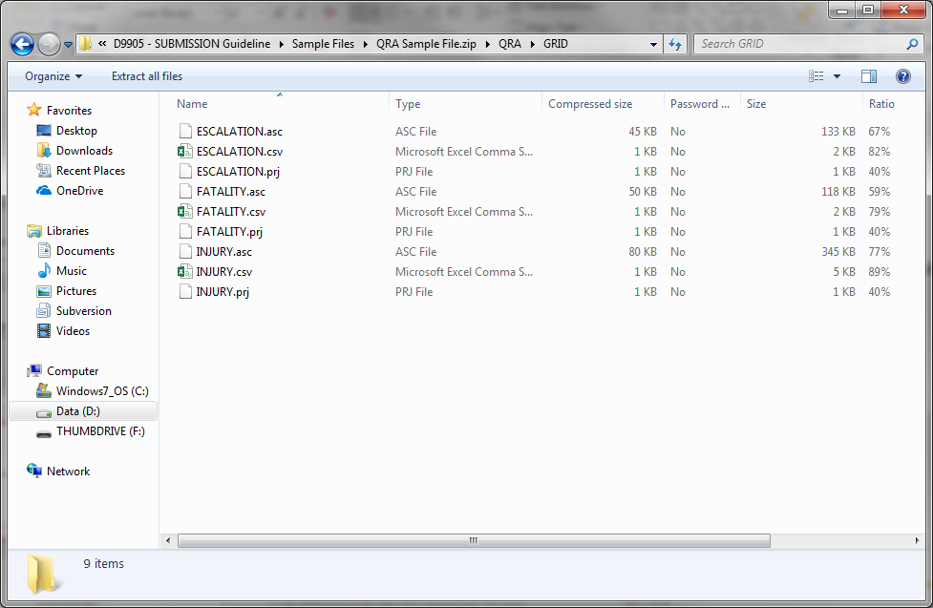  Figure 8 Sample files under GRID folder
- System only processes ASC or CSV format for Risk Grid.
- If it is ASC file, it MUST BE accompanied by a .PRJ file. (which is a Projection file that specifies the coordinate system)
- If it is CSV file, please ensure it is in SVY21 coordinate system.
- For the Risk Grid CSV files, the header of the fields MUST BE named as the following
- X: (decimal)
- Y: (decimal)
- Risk: (string)
- The Risk Grid files MUST BE named as following:
  - For Fatality: FATALITY.asc + FATALITY.prj OR FATALITY.csv
  - For Injury: INJURY.asc + INJURY.prj OR INJURY.csv
  - For Escalation: ESCALATION.asc + ESCALATION.prj OR ESCALATION.csv

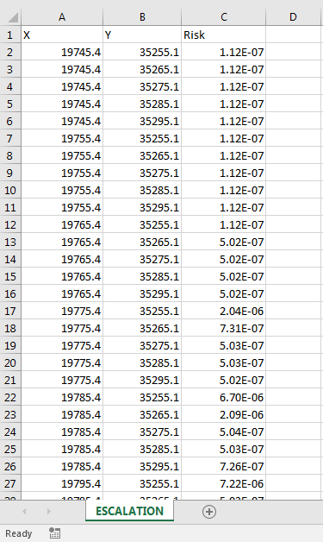
Figure 9 Sample risk grid csv file details for ESCALATION.csv
 |  | PDF (Sub Folder) | Contains the QRA Submission Report(s) in .PDF format [COMPULSORY], multiple PDF files are allowed, NO Restrictions on file name.  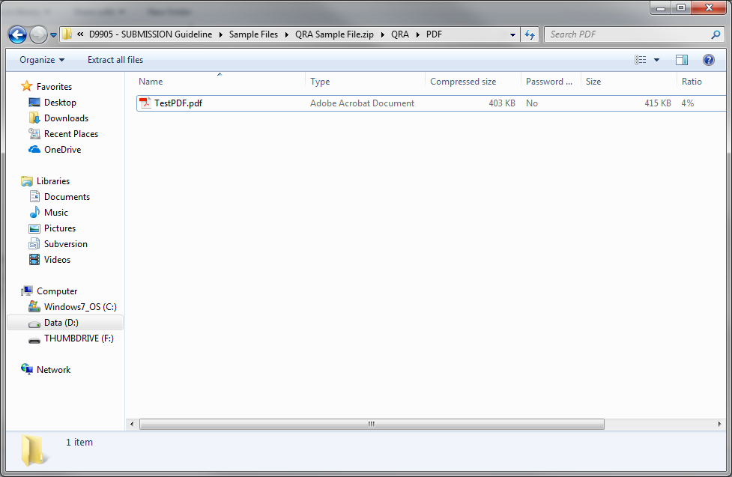  Figure 10 Sample files under PDF folder
 |  | SHP (Sub Folder) | Contains the relevant SHAPEFILEs pertaining to the QRA  - As mentioned in Section 2.1.2 of QRA Submission Guidelines, .shp, .shx and .dbf files are compulsory for SHP files.  These files come in a set; e.g. when the SHP files is generated/exported; the other files are also automatically generated. Please provide all the files generated for the shapefile (e.g. .cpg, .sbn, .sbx) if possible.  - With or without PRJ file, data must be exported in SVY21 coordinate system  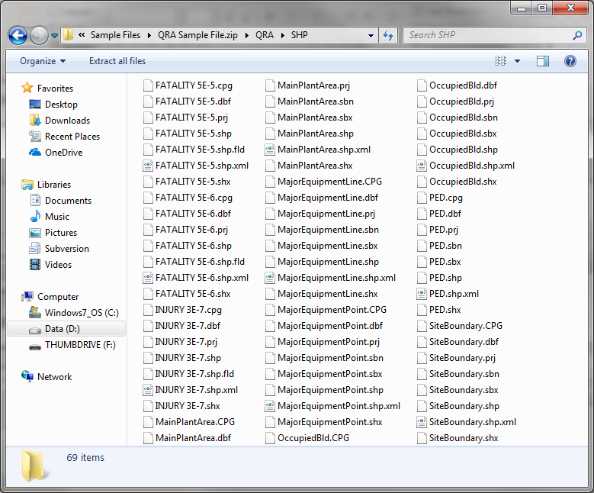  Figure 11 Sample files under the SHP folder
IR Contours SHP Files [COMPULSORY]
- IR Contour SHP file MUST BE named as <Category>[SPACE]<Harm Level>.
For example: FATALITY 5E-6.shp, INJURY 3E-7.shp, ESCALATION 1E-4.shp
- The feature MUST BE Polygon
- The following are valid Category for IR Contours:
  - FATALITY
  - INJURY
  - ESCALATION
- If no IR contour is generated, to provide a dummy or empty Shapefile. You can get the dummy or empty shapefile from QRA Empty.zip file attached below.

Please refer to Table below for the shapefile MUST HAVE fields/schema. Additional fields can be included in the shapefile without any impact to the system.:

Field Name | Data Type | Data Size | Optional / Compulsory | Remarks
FID | Object ID | - | Compulsory | Necessary field generated as part of Shapefile.
Shape | Geometry | - | Compulsory | Necessary field generated as part of Shapefile.
NAME | Text | - | Compulsory | Any arbitrary naming for the file
Factory_No | Short Int | - | Compulsory | Factory number
Road_Name | Text | 255 | Compulsory | Road name
Postal_Code | Text | 6 | Compulsory | Postal code
Company_Name | Text | 255 | Compulsory | Company name
Address | Text | 255 | Compulsory | Address

MainPlantArea.shp [COMPULSORY] – MUST BE named as “MainPlantArea.shp” only.
- Contains the Main Plant Area of the QRA report. All main plant area items MUST BE included in this single shape file
- The feature MUST BE Polygon
- If no data, to provide as dummy or empty shapefile. You can get the dummy or empty shapefile from QRA Empty.zip file attached below.

Please refer to Table below for the shapefile MUST HAVE fields/schema. Additional fields can be included in the shapefile without any impact to the system.:

Field Name | Data Type | Data Size | Optional / Compulsory | Remarks
FID | Object ID | - | Compulsory | Necessary field generated as part of Shapefile.
Shape | Geometry | - | Compulsory | Necessary field generated as part of Shapefile.
LABEL | Text | 1073741822 | Compulsory | Unique identifier for the plant area
TYPE | Text | 500 | Compulsory | Describes the type of the plant; e.g. Tank farm, Jetty, Truck Bay

MajorEquipmentLine.shp [COMPULSORY] – MUST BE named as “MajorEquipmentLine.shp” only.
- Contains Major Equipment (e.g. Pipe racks). All major equipments (line) items MUST BE included in this single shape file
- The feature MUST BE Polyline
- If no data, to provide as dummy or empty shapefile. You can get the dummy or empty shapefile from QRA Empty.zip file attached below.

Please refer to Table below for the shapefile MUST HAVE fields/schema. Additional fields can be included in the shapefile without any impact to the system.:

Field Name | Data Type | Data Size | Optional / Compulsory | Remarks
FID | Object ID | - | Compulsory | Necessary field generated as part of Shapefile.
Shape | Geometry | - | Compulsory | Necessary field generated as part of Shapefile.
ISOSECTID | Text | 50 | Compulsory | The unique iso-section id
ISOSECTDES | Text | 1073741822 | Compulsory | Description on the iso-section
Material | Text | 1073741822 | Compulsory | Material info

MajorEquipmentPoint.shp [COMPULSORY] – MUST BE named as “MajorEquipmentPoint.shp” only.
- Contains Major Equipment (e.g Tanks, etc…). All major equipments (point) items MUST BE included in this single shape file
- The feature MUST BE Point
- If no data, to provide as dummy or empty shapefile. You can get the dummy or empty shapefile from QRA Empty.zip file attached below.

Please refer to Table below for the shapefile MUST HAVE fields/schema. Additional fields can be included in the shapefile without any impact to the system.:

Field Name | Data Type | Data Size | Optional / Compulsory | Remarks
FID | Object ID | - | Compulsory | Necessary field generated as part of Shapefile.
Shape | Geometry | - | Compulsory | Necessary field generated as part of Shapefile.
ISOSECTID | Text | 50 | Compulsory | The unique iso-section id
ISOSECTDES | Text | 1073741822 | Compulsory | Description on the iso-section
Material | Text | 1073741822 | Compulsory | Material info

OccupiedBld.shp [COMPULSORY] – MUST BE named as “OccupiedBld.shp” only.
- Contains occupied building. All occupied building items MUST BE included in this single shape file
- The feature MUST BE Polygon
- If no data, to provide as dummy or empty shapefile. You can get the dummy or empty shapefile from QRA Empty.zip file attached below.

Please refer to Table below for the shapefile MUST HAVE fields/schema. Additional fields can be included in the shapefile without any impact to the system.:

Field Name | Data Type | Data Size | Optional / Compulsory | Remarks
FID | Object ID | - | Compulsory | Necessary field generated as part of Shapefile.
Shape | Geometry | - | Compulsory | Necessary field generated as part of Shapefile.
BLDID | Text | 50 | Compulsory | Unique building id
BLDTYPE | Text | 50 | Compulsory | Building type
ESTNOPPL | Long Integer | 10 | Compulsory | Estimated number of people
PROTMEASUR | Text | 1073741822 | Compulsory | Protection measures

PED.shp [COMPULSORY] – MUST BE named as “PED.shp” only.
- Contains PED information. All PED items MUST BE included in this single shape file
- The feature MUST BE Polygon
- If no data, to provide as dummy or empty shapefile. You can get the dummy or empty shapefile from QRA Empty.zip file attached below.

Please refer to Table below for the shapefile MUST HAVE fields/schema. Additional fields can be included in the shapefile without any impact to the system.:

Field Name | Data Type | Data Size | Optional / Compulsory | Remarks
FID | Object ID | - | Compulsory | Necessary field generated as part of Shapefile.
Shape | Geometry | - | Compulsory | Necessary field generated as part of Shapefile.
PEDDESC | Text | 1073741822 | Compulsory | Description
VOLUME | Long Integer | 10 | Compulsory | PED volume (m3)

SiteBoundary.shp [COMPULSORY] – MUST BE named as “SiteBoundary.shp” only.
- Contains Site Boundary. All site boundary MUST BE included in this single shape file
- The feature MUST BE Polygon
- If no data, to provide as dummy or empty shapefile. You can get the dummy or empty shapefile from QRA Empty.zip file attached below.

Please refer to Table below for the shapefile MUST HAVE fields/schema. Additional fields can be included in the shapefile without any impact to the system.:

Field Name | Data Type | Data Size | Optional / Compulsory | Remarks
FID | Object ID | - | Compulsory | Necessary field generated as part of Shapefile.
Shape | Geometry | - | Compulsory | Necessary field generated as part of Shapefile.
NAME | Text | - | Compulsory | Any arbitrary naming for the file

Please refer to the sample zip file:

Please refer to the below zip file for dummy or empty shapefiles for the various categories:

To be consistently referenced for all relevant sections in the report and corresponding additional submissions in other file formats where relevant (for e.g. CSV/shapefile submissions).
Include % dilution, mixture composition or composition ranges if appropriate.
Toxic by inhalation/highly flammable/pyrophoric/explosive/emits toxic fumes in a fire or in contact with water/low Self Accelerating Decomposition Temperature (SADT) etc.
Solid/Liquid/Gas.
Storage tank, reactor, distillation column, pipeline etc. For transport: drum/cylinder/ISO Container/details of packaging etc.
Convert all units to kilograms (kg) or metric tons (MT).
To be consistently referenced for all relevant sections in the report (e.g. Section 2.2.3 for iso-section ID) and corresponding additional submissions in other file formats where relevant (for e.g. CSV/shapefilefile submissions).
Brief source term information e.g. catastrophic failure or hole size, substance etc. Further details should be included in Section 2.2.3.
Include % dilution; mixture composition or composition ranges if appropriate.
If any identified scenarios have not been included for quantification, then these should be identified with justification for their non-inclusion.
The Outcome ID. To be consistently referenced for all relevant sections in the report and corresponding additional submissions in other file formats where relevant (for e.g. CSV/shapefile submissions).
X-coordinates of the equipment. This location refers to release point for equipment item, or start/turning point/end points for pipelines, and should be consistently referenced for all relevant sections in the report and corresponding additional submissions in other file formats where relevant. For pipelines, the coordinates must be separated by “|” character.
Y-coordinates of the equipment. This location refers to release point for equipment item, or start/turning point/end points for pipelines, and should be consistently referenced for all relevant sections in the report and corresponding additional submissions in other file formats where relevant. For pipelines, the coordinates must be separated by “|” character.
Iso-section ID. To be consistently referenced for all relevant sections in the report and corresponding additional submissions in other file formats where relevant (for e.g. CSV/shapefile submissions).
Category refers to WCS, WCS-offsite (WCS-O), CE and CE-offsite (CE-O). The exact abbreviation must be used: WCS, WCS-O, CE, CE-O
The Outcome description. To represent the event outcome and the harm level in the following format: Event Outcome, Harm Level OR Event Outcome at Harm Level
Footprint dimension (d). Footprint dimensions for circular footprints should be presented as d=x, -d=x, dmw=0, mw=2*x
Footprint dimension (-d). Footprint dimensions for circular footprints should be presented as d=x, -d=x, dmw=0, mw=2*x
Footprint dimension (dmw). Footprint dimensions for circular footprints should be presented as d=x, -d=x, dmw=0, mw=2*x
Footprint dimension (mw). Footprint dimensions for circular footprints should be presented as d=x, -d=x, dmw=0, mw=2*x
Report date, to be provided in the following format: DD/MM/YYYY
To be consistently referenced for all relevant sections in the report and corresponding additional submissions in other file formats where relevant (for e.g. CSV/shapefile submissions).
Including release rate & duration, mass released (in the largest applicable unit).
Absolute distance from point source to contour.
To be consistently referenced for all relevant sections in the report and corresponding additional submissions in other file formats where relevant (for e.g. CSV/shapefile submissions).
Absolute distance from point source to contour.
Absolute distance from point source to contour.
To be consistently referenced for all relevant sections in the report and corresponding additional submissions in other file formats where relevant (for e.g. CSV/shapefile submissions).
Absolute distance from point source to contour.
To be consistently referenced for all relevant sections in the report and corresponding additional submissions in other file formats where relevant (for e.g. CSV/shapefile submissions).
Absolute distance from point source to contour.
To be consistently referenced for all relevant sections in the report and corresponding additional submissions in other file formats where relevant (for e.g. CSV/shapefile file submissions).
The fraction of time for which population is present in the building.
X-coordinate of the occupied building.
Y-coordinate of the occupied building
To be consistently referenced for all relevant sections in the report and corresponding additional submissions in other file formats where relevant (for e.g. CSV/shapefile submissions).
To be consistently referenced for all relevant sections in the report and corresponding additional submissions in other file formats where relevant (for e.g. CSV/shapefile submissions).
Absolute distance from point source to contour.
To be consistently referenced for all relevant sections in the report and corresponding additional submissions in other file formats where relevant (for e.g. CSV/shapefile submissions).

