COMPANY’S NAME
COMPANY REGISTRATION NO
ADDRESS
TEL/FAX
EMAIL ADDRESS

TRANSPORTATION EMERGENCY RESPONSE PLAN

FOR
TRANSPORTATION OF HAZARDOUS CHEMICALS
WITHIN SINGAPORE

NAME(S) OF LICENCE HOLDER(S) | LICENCE NO. | VALIDITY | SIGNATURE

PREPARED BY:
NAME :
NRIC NO:
DATE:
SIGNATURE: |  | COMPANY STAMP:
Contents |  |  | Page
Contents Page |  |  | 1
Schedule(s) Of Clearance |  |  | 2
Main Plan |  |  | 3
1 | Situation |  | X
 | a | Introduction | X
 | b | Areas Of Operations | X
 | c | Vehicle/Tanker/Container Description | X
 | d | Hazard & Risk Assessment | X
2 | Aim |  | X
3 | Execution |  | X
 | a | Concept Of Operation | X
 | b | Action By The Transport Company/Personnel During Emergency | X
 | c | Grouping & Tasks | X
 | d | Coordinating Instructions | X
4 | Service Support |  | X
 | a | Equipment | X
 | b | Manpower | X
5 | Command & Signal |  | X
 | a | Command | X
 | b | Signal | X
6 | Annexes |  | X
 | Annex A - Routes Of Transportation (Highlighted Singapore Map) |  | X
 | Annex B - Summary Table Of Hazardous Chemical Transported |  | X
 | Annex C - Product/Chemical SDS |  | X
 | Annex D - Tables Of Grouping & Tasks |  | X
 | Annex E - Valid Hazardous Material Driver Permit |  | X
 | Annex F - Table Of Approved Vehicle/Container/Tanker No. |  | X
 | Annex G - Other Information Including Descriptions Of Container/Tanker |  | X
 | Annex H - Photo Of Approved Vehicles (Showing Front, Side & Rear Of The Vehicles) |  | X

Schedule(s) of Clearance

TRANSPORTATION EMERGENCY RESPONSE PLAN

TRANSPORTATION OF HAZARDOUS CHEMICALS WITHIN SINGAPORE

- SITUATION

a Introduction

b Area of Operations

(1) General

(a) Routes of Transportation

(b) Areas Surround Transport Route

(c) Approved Transport Time

c Hazard & Risk Assessment

(1) Hazard of Product

(2) Possible Scenarios

(3) Worst Case Scenario

d Vehicle/Tanker/Container Descriptions

(1) Design of the vehicle / Tanker / Container

(2) Maintenance

(3) Emergency Information

2 AIM

The aim of this emergency plan is to detail the various preventive measures & operational action that need to be taken by company/licence holder/driver, in case of a spillage, leak or fire during road transportation of hazardous chemicals.

3 EXECUTION

a Concept of Operation

(1) The emergency operation to be conducted in phases as follows :-

Phase Action

I Transportation personnel / escort party (if any) to carry out initial containment activities & alert the chemical company & SCDF (Call 995)/Police (Call 999).

II SCDF predetermined turnout response to the scene for containment & rescue activities.

III To conduct major operations for containment & minimise risks with other related agencies.

IV To clean up/decontaminate & resume normal operations.

b Emergency Actions by Transport Company/Driver/Escorting Personnel

c Grouping & Tasks

See Annex D

d Co-Ordinating Instructions

(1) Key Personnel Emergency Contact Numbers

(2) Government/Other Related Organisations

(3) Sectorization

The incident site will be sectorised into HOT, WARM & COLD zone during emergency. The definition of the various zones are as follows :-
Hot Zone | – | This is the area around the incident vehicle/tanker/container that required all personnel entering to be fully protected by means of BA sets & proper protective clothing & to be decontaminated upon leaving the zone.
Warm Zone | – | This is the area directly outside Hot Zone. All personnel in this zone should be equipped with Breathing Apparatus & if situation requires, done the mask for full protection against toxic hazard gases.
Cold Zone | – | This is a non-hazard zone outside the Warm Zone.

(4) Reporting / Alerting SCDF

The message to be used to activate SCDF & Police Force during emergency shall include the following information :-

      - Location of the incidents.

      - Type of incident.

      - Chemical involved.

      - Leakage with or without fire.

      - Transport company & chemical company name & contact number.

      - Casualties involved.

(5) Safety

- SERVICE SUPPORT

a Equipment

(1)

(2)

(3)

b Manpower

- COMMAND & SIGNAL

a Command

During the emergency, the transport personnel shall try all necessary action to contain the emergency. On arrival, SCDF shall takeover command of the operation with the support of the transport/chemical company.

b Signal

SCDF will set up the necessary communications facilities for the operations.

Annex A
Routes of Transportation
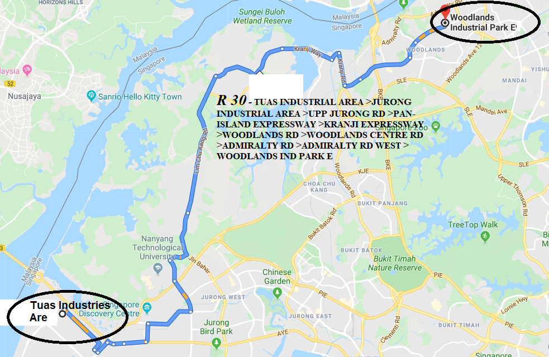
SAMPLE

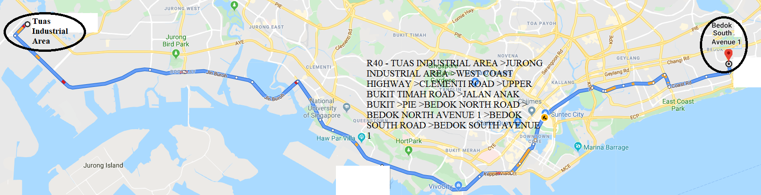
SAMPLE

Annex B
Summary Table of Hazardous Material Transported

S/N | Chemical/Product Name | IMDG Class | Type/Form | Max Approved Capacity transported per vehicle or container/per trip for import & export (via PSA Port, Tuas Link, Penjuru, Jurong Port or Changi Cargo Terminal (in kg or MT) | Max Approved Capacity transported per vehicle or container/per trip for local deliveries (if any please state location) to clients where applicable (in kg or MT) | Packing Type & Quantity per Packages

Annex C
Product/Chemical Safety Data Sheet (SDS)

Annex D
Table of Grouping & Tasks

S/N | GROUPING | GENERAL TASKS | PHASE | DETAILED TASKS | REMARKS
1 | Driver/  Assistant/  Escort Party | - To carry out Initial action to contain the leakage  - To alert SCDF & transport company.  - To minimise the risk to people. | I | - To Keep people away and control traffic flow.  - To put off incipient fires using portable extinguishers.  - To minimise spillage if possible.  - To activate police/SCDF.  - To contact the responsible company for the occurrence. | SCDF (call 995)  Police (call 999)  Key Personnel Nos:
 |  |  | II | To report to responding SCDF personnel to explain situation and provide assistance whenever possible.
 |  |  | III | To continue assisting SCDF.
 |  |  | IV | - To recover vehicle/tanker/container.  - To clear the incident site.
2 | Company  Technical  Expert/  Response  Team | - To assist SCDF to contain the leakage/fire.  - To provide specialise advice and equipment (if any) to contain spillage/fire.  - To implement recovery activities when is under control. | I | Prepare all necessary equipment suitable (if any)  For the incident. | Listed down the responsible company for the carry out process. Information required:  - Name of company  - Address of company  - Contact No. (office hour and after office)  - Contact Person
 |  |  | II | - To proceed to the incident site on activation.  - To report to SCDF personnel on site and give technical advice and other support.
 |  |  | III | Continue to assist SCDF in the operation.
 |  |  | IV | To carry out recovery and decontamination of the incident site.

Annex E
Valid Hazardous Material Driver Permit(s) HDTP

Annex F
Table of Approved Vehicle/Container/Tanker Registration No.

S/N | Vehicle/Prime-Over/Lorry |  |  | Trailer |  |  | Tanker/Lorry/Van/20 or 40 footer Container |  |  |  | Storage Condition of the Chemical
 | Reg No. | LTA Expiry Date | Owner’s Company | Reg No. | LTA Expiry Date | Owner’s Company | Type &  Reg No. | Expiry Date | Total Capacity | Owner’s Company | Name | Physical State | Storage Temp | Storage Pressure
1 | NAK 2610 | Nov 2004 | XYZ | T/N 2871 | Nov 2004 | XYZ | IMO 1  TPMU 141033-1 | Aug 2003 | Tanker  20000 litres | ABC | Acetic Acid | Liquid | 25°C | 6 bar
2 | YK 8111G | Dec 2003 | MNO | - | - | - | Lorry  YK 8111G | Dec 2003 | Cylinder  300 kg  (6 cylinders) | MNO | LPG | Gas | 25°C | 1 bar
3 | XB 6873M | Jun 2003 | ACS | - | - | - | Tanker  XB 6873M | Jun 2003 | Tanker  26000 litres | MNO | Ethane | Liquid | XX°C | X bar
4 | YKA  1111 | Jun 2003 | ACX | - | - | - | Container (20ft)  AAA 1111111 | Jun 2003 | Drums  20000 kg  (80 drums) | ACX | TDI | Liquid | Normal Room Temp | Normal atmospheric pressure
5 | YKA  1111 | Jun 2003 | AXX | - | - | - | Container  (20 ft)  Depend on shipping line | Depend on shipping line | Drums 2000 kg (80 drums) | Depend on shipping line | TDI | Liquid | Normal Room Temp | Normal atmospheric pressure

Annex G
Other Information including Descriptions of Container/Tanker

Annex H
Photo of Approved Vehicles

S/N | Vehicle Reg No | View
 |  | Front | Side | Rear
1 | AB1234Z | *Colour: White | 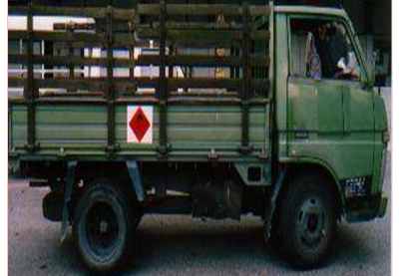  *Colour: Green | 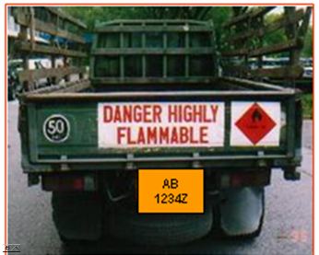  *Colour: Green

