Appendix 2: Site Environmental Control Programme

Instructions
- The ECO(SCS) and Occupier shall prepare and submit the SECP respectively within one month after the commencement of works on the specified construction site, to the National Environmental Agency (NEA) via FormSG. https://go.gov.sg/ecosecp

QR Code for Weblink

2) The ECO(SCS) and Occupier shall update and resubmit the SECP if:
a. There is a change in ECO(SCS);
b. There is a change in General Waste Collector (GWC) and/ or Vector Control Operator (VCO);
c. There are any updates and/ or changes Environmental Management Plan; or
d. There are any changes to the Site Layout

3) As there is no autosave or save as draft feature, you are advised to prepare the information required before starting the submission process.

4) Please attach the PDF version of the endorsed Declaration Form in Section E

One- Time Password Authentication
A verification code will be sent to the email address provided below.

Email: ____________

Section A: General Details

1. Is this a revision of a previously submitted SECP?
(Yes/ No)
If Yes: What amendment(s) was made? (Please tick the checkbox given in FormSG)
a. Change in ECO(SCS)

Change in General Waster Collector (GWC) and Vector Control Operator (VCO)

c. Changes in Environmental Management Plan

Change in Site Layout
If No: please complete Sections A – D below

Details of Construction Site
2. Name of Construction Company
Please state the company name in full

3. BCA Project Reference No.
e.g. E0123-00001-2002-ST01

4. Division of Construction Site
Please select the Division where the Construction Site is located. If the site spans across multiple Divisions, please use Site Office as the reference point.

5. Address of Construction Site and Land Lot Number
e.g. 123 Singapore Road Singapore 123456 Lot 12345C MK01

6. Contract Sum of Project
Please state the contract sum of the Project in SGD. (e.g. 50000000)

7. Number of Workers housed in on site
Please state the total number of workers staying on site. (e.g. 30)

8. Commencement Date from Letter of Award (LOA)
Please state the date in (DDMMYYYY) format.

Section B: Details of ECO(SCS)
If Question 1 “Is this a revision of a previously submitted SECP” is “Yes”,
10. I will like to notify on a change in ECO(SCS).
(Yes/No)
If Yes:
10a. Name of Outgoing ECO(SCS)
Please state the full name of the Outgoing ECO(SCS).

10b. Outgoing ECO(SCS) Registration Number
Please state the Registration Number (e.g. FXXXXR, SXXXXQ, SXXXXP) of the outgoing ECO(SCS).

10c. Contractual Start Date of Outgoing ECO(SCS)’s Appointment
Please state the date in (DDMMYYYY) format.

10d. Contractual End Date of Outgoing ECO(SCS)’s Appointment
Please state the date in (DDMMYYYY) format.

11e. Reason for Discontinuing Employment
Please state the reason for discontinuing employment. (e.g. Not fulfilling the duty and responsibilities of an ECO(SCS).

If No: Please Proceed to the next Question

11. Details of ECO(SCS) Appointment

Name of Appointed ECO(SCS) | ECO(SCS) Registration Number (e.g. FXXXXR, SXXXXQ, SXXXXP) | Type of Appointment | Contact Number | Contractual Start Date of ECO(SCS) (DDMMYYYY)
Please state the full name of the appointed ECO(SCS). | Please state the Registration Number (e.g. FXXXXR, SXXXXQ, SXXXXP) of the appointed ECO(SCS). | Full-Time/ Part- Time | Please provide the local contact number (without country code) of the appointed ECO(SCS) e.g. 91234567 | Please state the date in (DDMMYYYY) format.  e.g. 24062020 (24 June 2020)
*Use the “+ Add More” element in FormSG if required.

12. Contact Information of Project Manager

Name of Project Manager | Email Address | Contact Number
Please state the full name of the Project Manager. | Please provide the email address of the Project Manager. | Please provide the local contact number (without country code) of the Project Manager  e.g. 91234567.

Section C: General Waste Collector (GWC) and Vector Control Operator (VCO)
Details of General Waste Collector (GWC) engaged
(Occupier must update and re-submit the SECP when the GWC is changed.)

13. Name and licence number of GWC (Class A/B)

Name of GWC | Licence number of GWC (e.g. TXXXXXXXXL)
Please state the full name of Class A/B GWC) | Please state the licence number of Class A/B GWC)

*Use the “+ Add More” element in FormSG if required.

14. Name and licence number of GWC (Class C)
Name of GWC | Licence number of GWC (e.g. TXXXXXXXXL)
Please state the full name of Class C GWC) | Please state the licence number of Class C GWC)

*Use the “+ Add More” element in FormSG if required.

15. Details of Vector Control Operator (VCO) engaged
(Please state if more than one VCO will be engaged)
(Occupier must update and re-submit the SECP when the VCO is changed)

Name of VCO | Licence number of VCO (e.g. VCOXXXXXXXX) | Contractual Start Date of VCO (DDMMYYYY) | Contractual End Date of VCO (DDMMYYYY)
Please state the full name of VCO | VCO01012020 | e.g. 24062020 (24 June 2020) | e.g. 24062020 (24 June 2020)

*Use the “+ Add More” element in FormSG if required.

Section D: Declare Environmental Management Plans
Please provide detailed environmental management plans (D1 - D6). Reasons should be provided if sites fail to implement the required plans. The file size is limited to 3MB.

D1. Site Layout
16. Please indicate the total area of the construction site
Please state the total area in m²

17. Please attach the Site Layout that shows the following areas:
Maximum of 1 attachment of 3MB file size

a) Waste collection point(s) accessible to waste collection vehicles
b) Paved main access roads, with wash bay
c) Workers Quarters
d) Toilet Facilities
e) Canteens and/or rest areas for meals

Example of Site Layout:
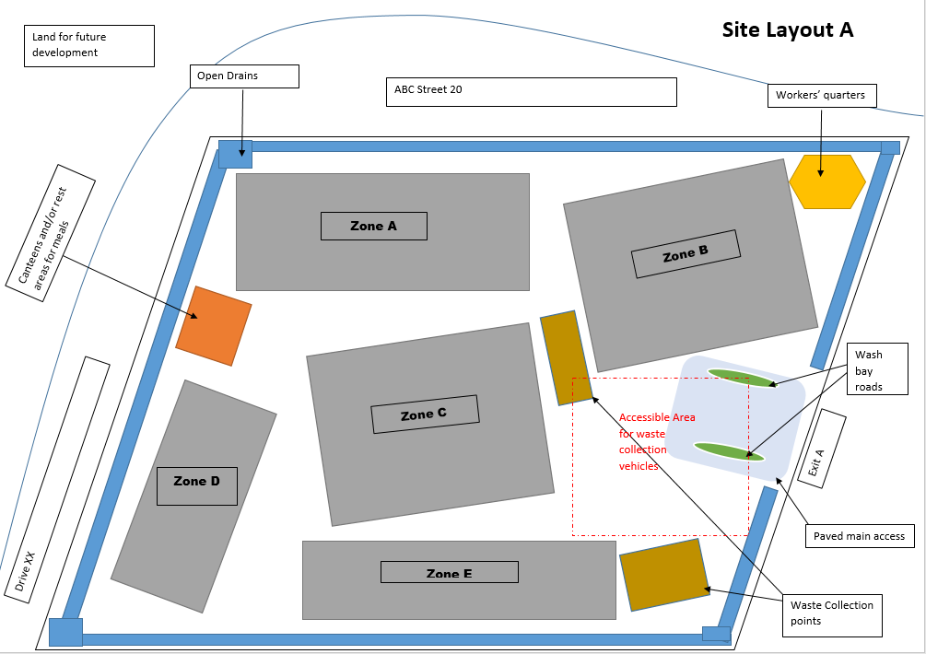

D2. Vector Control Programme
Surveillance

Please describe in detail:
1. high-risk areas to inspect and,
2. the inspection frequency of such areas

across the different stages of your construction work (Preliminary works, Sub-structure stage, Building Stage till TOP)
a) Preliminary works
b) Sub-structure stage
c) Building Stage till TOP

18. | Surveillance (Preliminary works)
Example

- The area is segmented into 6 zones with a vector control team in charge of each zone. The supervisor of each team would inspect their area for environmental issues as and when they see it. The zoning method applies across all stages of work.

- Weekly inspection for uneven grounds, receptacles (e.g. bins, drainage outlets, containers & pails), canvas sheets, plants and fallen leaves for stagnant water

- Please state other high-risk areas identified by the ECO(SCS) with the recommended frequency of inspection.

19. | Surveillance (Sub-structure stage)
Example

- Weekly inspection for all barriers to ensure that they are in good conditions with no cracks or damages.

- Gutter and scupper drains. Weekly inspection to ensure that drains are not choked due to fallen leaves

- Please state other high-risk areas identified by the site’s ECO(SCS) with the recommended frequency of inspection.

20. | Surveillance (Building Stage till TOP)
Example

- Weekly inspections of gully traps, sinks, toilet bowls, inspection chamber covers, corridors and staircase landings, scupper drains and storage yard for stagnant water.

- Please state other high-risk areas identified by the site’s ECO(SCS) with the recommended frequency of inspection.

Mitigation Measures

Please describe in detail the mitigation measures on site (e.g. Clear overgrown vegetation and water-bearing receptacles) in different stages of work (Preliminary works, Sub-structure stage, Building Stage till TOP)
a) Preliminary works
b) Sub-structure stage
c) Building Stage till TOP

21. | Mitigation Measures (Preliminary works)
Example

- Test block stacking area to be designed by Professional Engineer and provide steel plate below test blocks to prevent depressions due to heavy loads.

- Regularly maintain and level uneven grounds.

- Provide slight gradient and proper drainage to allow water to flow towards drain and gutters.

- Carry out BTI misting for dense overgrowth, vast turfed areas and holes in tree trunks.

- Please state other mitigation measures suggested by the site’s ECO (SCS).

22. | Mitigation Measures (Sub-structure stage)
Example

- Drill holes on struttings and walers of fill them with sand to prevent collection of water.

- Provide sump at the lowest point and provide automatic pump to remove access water.

- Debris to be removed from site frequently to facilitate removal of stagnant water and insecticidal treatment.

- Please state other mitigation measures suggested by the site’s ECO(SCS).

23. | Mitigation Measures (Building Stage till TOP)
Example

- Seal off unused sink, toilet bowls, cisterns and gullies before handing over.

- Timber/ Raised decks should only be installed after passing the flow test.

- Apply granular insecticide in ponds and swimming pools until handing over.

- Provide grating for drains to prevent chokage due to fallen leaves.

- Please state other mitigation measures suggested by the site’s ECO(SCS).

D3. Waste Management
24. Is there a waste disposal monitoring framework in place? You may refer to Appendix 6 for a template for monitoring waste disposal in construction site.
(Yes/ No)

25. Are there enough bins provided for each type of waste to ensure no spillage at any time?
- Organic Waste (should be of SS EN 840 standard wheeled bin with maximum size of 660 litres and properly covered when not in use)
(Yes/ No)

- Construction Waste
(Yes/ No)

- Recyclables
(Yes/ No)

D4. Dust Abatement
26. Describe the dust abatement measures implemented.
Example

- Use of effective measures such as water sprinklers/ spray, shielding, netting, covers/ hoarding for aggregate and sand storage
- Proper storage of construction debris and disposal off site

27. Ensure that concrete batching plants must have a Written Permission (WP) from the Director, Pollution Control Department to occupy and operate as a Scheduled Premises. The operation of the concrete batching plant must comply with all the conditions stipulated in the WP.
(Yes/ No/ Not Applicable)
D5. Noise Control
For projects located within 150 metres from noise-sensitive premises, upon notice, you may be required to prepare a Noise Management Plan (NMP) with more details for submission to the NEA Pollution Control Department. For more information on regulations on Construction Noise, please visit the URL (https://sso.agc.gov.sg/SL/EPMA1999-RG2)

28. Describe the noise control measures implemented (e.g. Installation of noise barriers).

Example

- Minimise the usage of generators by setting up permanent power supply with the electricity provider. Generators are sited at locations that minimise the noise nuisance affecting nearby premises

D6. Earth Control
You are reminded to submit an Earth Control Management (ECM) Plan endorsed by a Qualified Erosion Control Professional (QECP) to the PUB Catchments and Waterways Division to obtain necessary clearance before earth works start. Please refer to https://www.pub.gov.sg/drainage/earthcontrolmeasures for more information on ECM.
29. Name of Earth Control Measures Officer
Please state the full name of the Earth Control Measures Officer responsible for the Project.
A Copy of the SECP submission will be forwarded to the following E-Mail(s)
30. Email address of ECO(SCS): __________
Please fill in the required field
31. Email address of Project Manager: __________
Please fill in the required field

Section E: Declaration Form

By submitting this form, I confirm that the information provided in the SECP is true and correct.

This SECP is prepared by:

___________________________
(Name and Signature of ECO(SCS)

and submitted by;

___________________________ _______________
(Name and Signature of Occupier) (Company Stamp)

Section E: Declaration Form
32. Please attach a signed PDF version of the declaration form below. The file size is limited to 3MB.
Maximum of 1 attachment of 3MB file size

